**Task Progress Update Report**

**Name: LIM SHI KAI (Sky)**

**1. Overview of Assigned Tasks**

**Task 1**: Adjust calibration for the X and Y axes

* **Objective**: Adjust the calibration of the X and Y axes by referring to Phang's code without directly copying it.
* **Assigned On**: 07-10-2024

**Task 2**: Implement CLAHE (Contrast Limited Adaptive Histogram Equalization)

* **Objective**: Apply CLAHE to the output for image enhancement.
* **Assigned On**: 07-10-2024

**2. Progress as of 17-10-2024**

**Task 1: Calibration for the X and Y Axes**

* **Current Status**: Completed
* **Details**:
  + The calibration adjustments for the X and Y axes have been **successfully** updated **after reviewing** Phang's code without directly copying it.
  + Presented the effect of calibration, demonstrating how it impacts the output.

**Task 2: CLAHE Implementation**

* **Current Status**: In Progress
* **Details**:
  + **Successfully** implemented **CLAHE** using the OpenCV library.
  + Presented the output with CLAHE applied, demonstrating how the **clipLimit parameter** can be **adjusted** through the **input field** to modify the effect.
  + Received four sets of raw data. Calibration was successful and **clear** for **two** sets. However, **one** data set **still** contains **some noise** in the axes, and **one** more set **failed** to show any results during the progress update.
  + 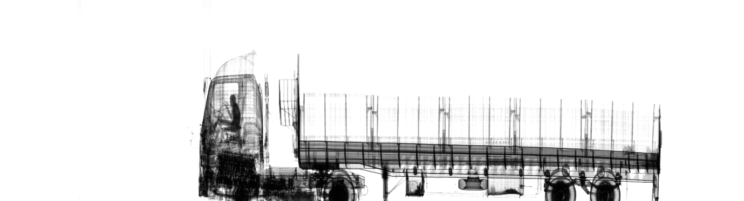**Image 1**: Output from raw data set 1, showing clear calibration results.
  + **A bridge with a bridge over it

    Description automatically generatedImage 2**: Output from raw data set 2, showing clear calibration results.
  + A close-up of a truck

    Description automatically generated**Image 3**: Output from raw data set 3, showing some noise in the axes.

**3. Next Steps and New Tasks (Received on 17-10-2024)**

**Task 1: CLAHE with GPU Implementation**

* **Objective**: Integrate CLAHE functionality using GPU acceleration, not limited to the OpenCV method.
* **Action Plan**: Explore and implement CLAHE with GPU methods, potentially using CUDA or other relevant libraries.

**Task 2: Calibration Method using Gan Heng Lai’s Code**

* **Objective**: Refer to Gan Heng Lai's code and method to perform X and Y axis calibration more efficiently.
* **Action Plan**: Investigate Gan Heng Lai’s flow and adapt it for current use without directly copying the code.

**Task 3: Apply Threshold to CLAHE for Dark Areas**

* **Objective**: Implement CLAHE in such a way that it enhances only certain parts of the image that are dark, leaving the rest unchanged.
* **Action Plan**: Integrate a threshold value as an input parameter for CLAHE to focus on dark areas, with an adjustable input field to specify the desired threshold.

**Task 4: OOP Refactoring**

* **Objective**: Refactor the current code, breaking down the CLAHE implementation and calibration adjustments into multiple classes and files using Object-Oriented Programming (OOP) principles.
* **Action Plan**: Apply OOP concepts to transfer functionalities into distinct classes and ensure better code organisation.

**4. Roadblocks/Issues**

* One of the raw data sets continues to present noise in the X and Y axis calibration, requiring further investigation.
* One data set failed to display during the update, necessitating troubleshooting.

**5. Conclusion**

* The calibration and CLAHE tasks have been mostly completed, with successful outputs presented for CLAHE.
* Additional work is required on GPU integration, more complex CLAHE functionality for dark regions, and applying OOP principles to structure the code better.